**Note: To load the csv data to a numpy array, you could**

1. **Import the data to list and then create array using numpy.array**
2. **Use numpy.loadtxt()**

**Problem #1:**

**Step 1: Selecting Dataset**

* You need to select one data set. These datasets can be taken from the UCI Machine Learning Repository (<https://archive.ics.uci.edu/ml/datasets/Wine+Quality>).
* However, not all data sets are suitable for NumPy analysis. Therefore, you need to look at each data set, and test them if needed.
* In addition, you can select the other data sets from different repositories using Kaggle/Google datasets.

**Step 2: Importing the .csv files**

* Once you have downloaded your dataset, import the .csv library.
* Open and read the .csv file
* Test the dataset, to see if it works.

**Example:**

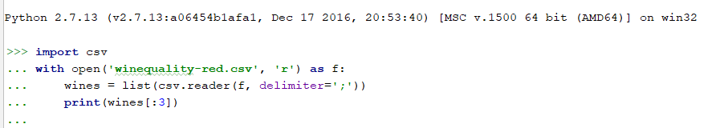

**Step 3: Importing the NumPy**

We import the NumPy package, and also create a NumPy array using the [numpy.array](http://docs.scipy.org/doc/numpy/reference/generated/numpy.array.html) function.

**Example:**



**Questions**

1. **Slicing array**
2. **Select first 5 items from the 4th column and display the values.**
3. **Select all rows of the 6th column and print the values.**
4. **Display all rows and columns.**
5. **Display 2nd item from 1st row.**
6. **Creation and Converting data types**
7. **Figure out what data type you are using and display the name.**
8. **Convert that data type into lower-bit (32) data type.**
9. **NumPy Array Operations**
10. **Increase the quality score of the wine by 15 points.**
11. **Display the wine which has high alcohol and quality content (highest score).**
12. **Find the sum of all elements in the array [6] of wines.**
13. **NumPy Comparisons**
14. **Find out among all wines which have their quality greater than 7.**
15. **Find out the wines which have quality equal to 5.**
16. **Using 1 Display all the wines which have the quality greater than 7.**
17. **Combining NumPy arrays**
18. **Display the shape of white wines, after combining it with:**
19. **Wines**
20. **Red wines**
21. **Display the white wines after combining it with:**
22. **Wines**
23. **Red wines**

*Problem #2:*

**Step 1: Selecting Dataset**

* You need to select one data set. These datasets can be taken from the UCI Machine Learning Repository (<http://archive.ics.uci.edu/ml/datasets/heart+disease>).
* However, not all data sets are suitable for NumPy analysis. Therefore, you need to look at each data set, and test them if needed.
* In addition, you can select the other data sets from different repositories using Kaggle/Google datasets.

**Step 2: Importing the .csv files**

* Once you have downloaded your dataset, import the .csv library.
* Open and read the .csv file
* Test the dataset, to see if it works.

**Example:**

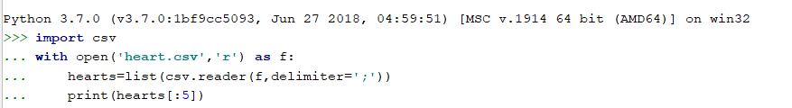

**Step 3: Importing the NumPy**

We import the NumPy package, and also create a NumPy array using the [numpy.array](http://docs.scipy.org/doc/numpy/reference/generated/numpy.array.html) function.

**Example:**



**Questions**

1. **Display first three rows.**
2. **Check if any of the row values for zeros.**
3. **Using random function to generate 7values and display it.**
4. **From the above, 3solution use shuffle function and display the values.**
5. **Display the minimum and the maximum value from the above generated array(4Q).**
6. **Set an array matrix for the first 5rows, display it and reorder the matrix to: (where, Hint: n=4)**
7. **1 x n**
8. **n x 1**
9. **Display the data type you are using for this dataset and state if the matrix if the rows can perform Eigen Vectors and Value computation without changing the dimension?**
10. **Randomly generate a 2dimensional matrix, display and compute it**
11. **Eigen Values**
12. **Eigen Vectors**